Project Proposal

Project title: Temporal Interpretability of Music Generation Models Via SAE Feature Activation Profiles
Authors: Alex Fraser | Spike Cheng

Link: Interpretability of LLMs Project Abstract

What are you trying to do? (200 words max)
In recent works, researchers found neural networks trained on music appear to have learned implicit theories of musical structure through statistical learning alone [1]. In Singh et al.’s paper, feature activations are averaged over entire tracks which collapses the time dimension. However, music fundamentally changes through time. We propose analyzing feature activations over time to reveal structural and narrative features that track-level averaging cannot show us.

How is it done today, and what are the limits of current practice? If someone (you? 😼) addresses identified limits, what difference will that make? (250 words max)
Singh et al. introduced a method for discovering interpretable concepts in music generators using sparse autoencoders (SAEs), extracting interpretable features from the residual stream of a transformer model (MusicGen), with automated labeling and validation pipelines to produce a single vector per track [1].

To be explicit, the current pipeline is roughly, Audio > MusicGen transformer > residual stream activations > SAE encoding > average across time (this is what we want to change) > label feature vector > finally interpretability analysis.

The core research we are challenging is the author's use of Temporal Collapsing, by averaging the activations. They do this by computing a mean activation across all time steps for each track, reducing the full residual stream down to a single scalar per feature per song.This let them ask whether this SAE feature corresponds to a recognizable musical concept, Which they found the answer was yes. With these results, it reveals that familiar musical concepts, such as genre, are encoded in an LLM, but fails to identify patterns recognizable in tracks such as a repeating chorus, guitar solo, or tension.

If we are able to fix this, by keeping the full activation time series rather than collapsing to a scalar, we would be able to distinguish four qualitatively different kinds of musical knowledge: Static properties (genre, instrument), structural markers (verse/chorus periodicity), narrative arcs (tension, fade out), and local events (drum fills, key changes). These are currently indistinguishable from each other in the existing framework. Additionally we would be able to shift the question from asking “does this model know music theory vocabulary?” to “does it encode musical narratives across time?”, a much deeper question, which may enable temporally targeted steering, e.g., “start building tension at the two minute mark”.

What is new in your approach and why do you think it will be successful? (500 words max)
Singh et al. treats each track as a bag of features such that order doesn't matter, only average presence does. The contribution we are proposing here is treating each feature as a time series and asking what its shape reveals. Rather than a single scalar, per feature track, we can preserve a matrix of activations [num_features] x [num_timesteps], then characterize the temporal profile of each feature across a corpus of full length songs.

By doing this the analytics shift from asking “does this feature have a high mean?” to ask whether it has a low variance (static), periodic autocorrelation or fourier time analysis (structural), monotonic trend (narrative arc), or a high kurtosis with isolated spikes (local events). Each of these is a well-understood signal processing or statistical operation which should not require model training.

Another change from the Singh et al. method is the length of track. Moving from 10-second clips to full-length tracks is a necessary condition for certain features to even be observable. Structural markers like a bridge or a climactic release are only meaningful relative to the full arc of the song. Therefore we cannot detect periodicity in 10 second clips, requiring analysis over full length songs.

To reduce computational complexity, we plan on using a sliding window approach, by running an existing SAE on overlapping chunks of a full track and stitching the activations together, we can avoid the cost of retraining while gaining temporal resolution. Should this method prove insufficient we will pivot to retraining an SAE over full length tracks.

The reason we believe that this approach will work is because SAE features learned on 10-second clips still fire meaningfully when applied to full tracks. This is plausible because features are encoding local acoustic and musical properties, this may include harmonic content, rhythmic density, or simply the texture of a sound.

The four temporal profiles and what they represent include:
Static Properties: features that should remain active across a song. (Genre, Instrumentation, etc.)
Structural Markers: features that activate (Usually periodically) to describe the ‘structure’ of a song (the intro, verse, chorus, bridge, etc.)
Narrative Arc: features that activate (gradually) when we ramp up, spike, or decay a narrative of a song. (building tension, climactic release, fading out, etc.)
Local Events: events that are brief and usually only occur once. (Drum fills, key changes, guitar solos, etc.)

To validate our method we can look at static features to see if they match Singh et al.’s discovery. If they do, we know that our sliding window method is working and we can expect results. Features that don’t match indicate the sliding window assumption has failed.

What are the midterm (after 2 weeks) and final exams (after a month) to check for success? If a user study does not fit as an evaluation for your problem, explain why. (200 words max)
For our midterm evaluation, we will run the sliding window pipeline on a small sample of 10-20 full tracks and verify that temporal activation matrices are being extracted correctly. The exact deliverable is a set of activation time series plots showing that different features visibly behave differently across time. We will have at least one example of each of the four profile types that should be clearly observable. Some potential outcomes of this is (1) a clean separation between profiles, (2) partial signal where some profile types emerge but others are noisy or ambiguous, or (3) no signal, which means we will have to pivot to train a new SAE on longer tracks.

For our final evaluation, a systematic classification of SAE features by temporal profile type across the full dataset, with qualitative validation showing features labeled with our profiles fire at their appropriate times (see above) using the labels from a database. This will replace a user study since there is nothing for a user to evaluate. The ground truth is the structure of the activations themselves, validated against musical annotation not human preference.

A plan of how the workload will be divided among teammates. (150 words max)
We plan on using Github for our project along with assigning tasks with the issues board. We will meet each week and discuss what we have done as well as what needs to be done so we can efficiently split up work. We plan on splitting up the workload evenly and working on project reports/posters together.

Additional notes:
[You can add extra notes, examples, references, etc. here.]
[1] (2505.18186) - Singh et al. Discovering and Steering Interpretable Concepts in Large Generative Music Models
[2] - 2601.14157v1 -Bruno Sienkiewicz, et al. ConceptCaps - a Distilled Concept Dataset for Interpretability in Music Models
[3] - Forum - Weyne Ma, Gus Xia, Exploring the Internal Mechanisms of Music LLMs: A Study of Root and Quality via Probing and Intervention Techniques
[4] - https://github.com/YatingMusic/remi - Remy Huang, Midi/Remi
[5] - 2503.05613 -Dong Shu, et al. A Survey on Sparse Autoencoders: Interpreting the Internal Mechanisms of Large Language Models
[6]2602.05027 - Georgii Aparin et al. AudioSAE: Towards Understanding of Audio-Processing Models with Sparse AutoEncoders

Intermediate Report
[Add this to your proposal and complete it.]

Repeat here your planned evaluation measurement for the intermediate report. If you realized that another measurement would be more appropriate, additionally describe it here, while still repeating what you initially planned. (max 150 words)

For our midterm evaluation, we will run the sliding window pipeline on a small sample of 10-20 full tracks and verify that temporal activation matrices are being extracted correctly. The exact deliverable is a set of activation time series plots showing that different features visibly behave differently across time. We will have at least one example of each of the four profile types that should be clearly observable. Some potential outcomes of this are (1) a clean separation between profiles, (2) partial signal where some profile types emerge but others are noisy or ambiguous, or (3) no signal, which means we will have to pivot to train a new SAE on longer tracks.

Our progress toward this evaluation has been somewhat successful so far, while we have managed to reach out to the original researchers of the paper we are attempting to expand [1], they don't plan to release their code until March 29th. Despite this problem we have decided to pivot and train our own SAE while we wait for the researchers to release their code.
If you managed to conduct that evaluation, share your results (a table or a plot) and comment on what the result tells you about the problem you aim to address so far. If you didn’t manage to conduct the evaluation, move on to the next question. (max 200 words without tables/plots)
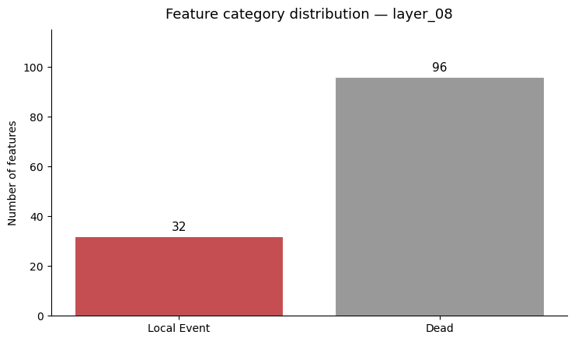
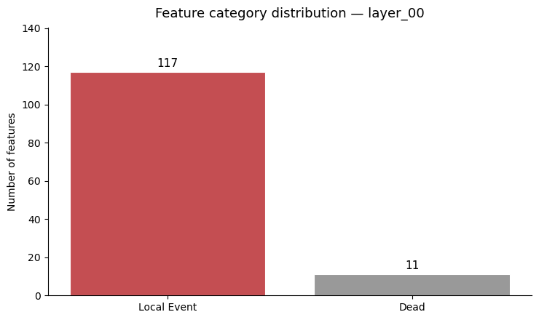

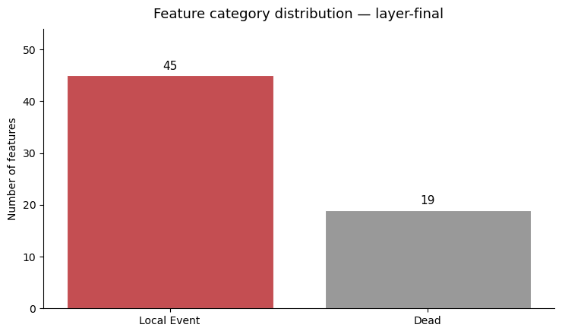
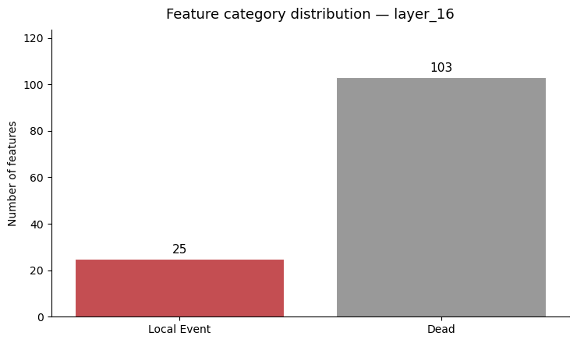
The above graphs show the number of dead versus active features extracted from the MusicGen SAE. Although the above graphs are able to show some local features exist, we were unable to get results yet in detecting other temporal profiles. This limitation was likely due to insufficient training of the SAE model. Up until this point, we have only run jobs on a macbook, but we plan to transition to the CHPC where Spike will work on training a more robust model.

These plots show us how each of the analyzed layers have trained. Despite not being able to detect features beyond local events, these plots do show how sparsity is increasing layer after layer until the final layer where there are more active features. This shows that our SAE is functioning somewhat as intended although it is unexplained why the final layer is not as sparse as the rest, it may be explained by the middle layers encoding more abstract/compressed representations while the final layer re-expands to interpretable features.
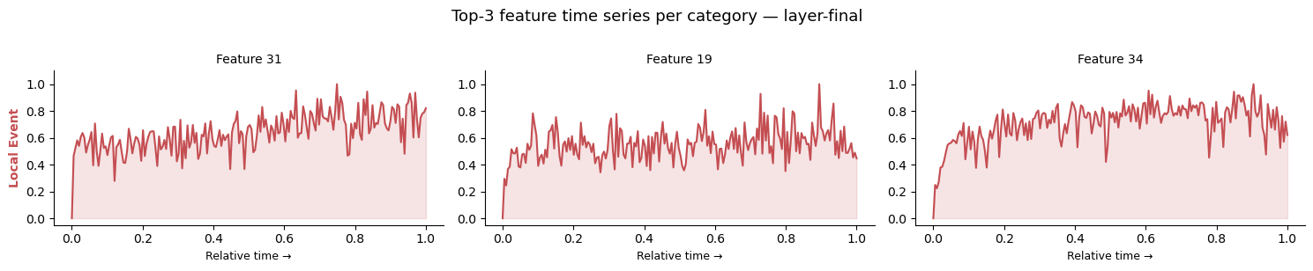
These plots show the top-3 activation through time in a track. What is interesting about this is these features remain fairly constant and active through time with small spikes throughout them. While we were unable to automatically label this as a static event, there is strong evidence that these may be static events since they remain fairly constant however this will require more analysis and tweaking.
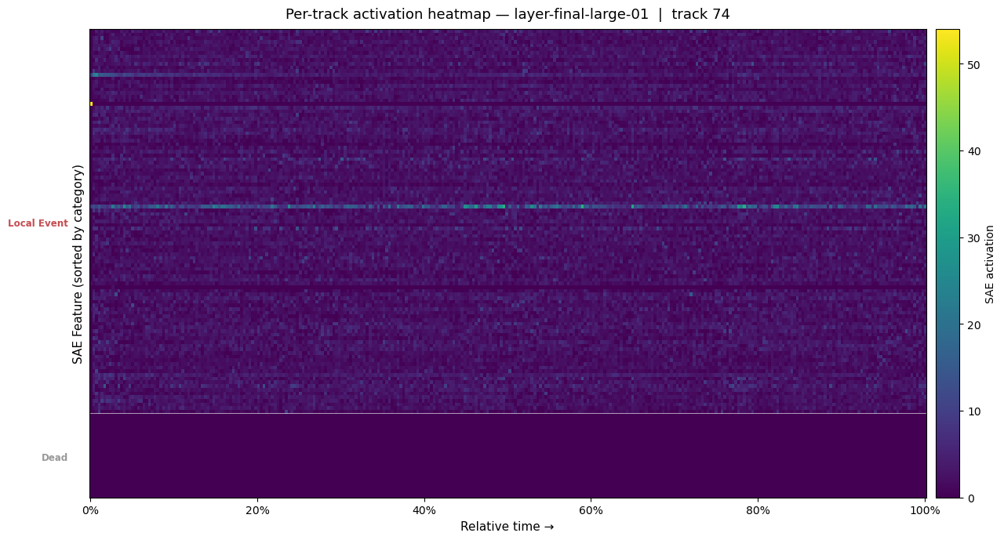
This plot shows feature activations through time. We can see that there is a strong activation for one specific local event. Another interesting feature is the one that decays at the beginning of the song and then appears to go dead, there is an argument to be made that this may be correlated with the intro of the song but requires further exploring.
If you haven’t managed to get concrete outcomes yet, describe what challenges you encountered that prevented you from achieving them. (max 150 words)

Some major challenges we have faced so far are the lack of training code, extracted features, and SAE from the original researchers. This obstacle forced us to pivot and train our own SAE instead of relying on the researchers’ model. Once the researchers release their code and extracted features we can compare our SAE to the performance of their SAE.
Check whether you need to revise your final evaluation, and if so, write what you aim to quantify in the following weeks instead. (max 150 words)
Despite our setbacks, we expect to be able to achieve our original final evaluation. Whether the researchers are able to release their code in time or not, we have plans to complete and use our own SAE instead of the researchers’, allowing us to achieve our final evaluation goals regardless.

Summary & Takeaways for Your Project from Peer Feedback
[Add this to your intermediate report and complete it.]

Poster Abstract

